Sami Nyckling, Sebastian Olsson, NV07A

Battle of Jerusalem

SCREENSHOTS

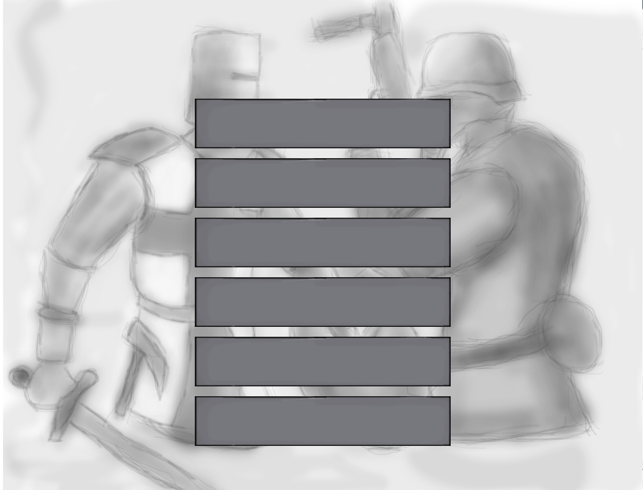
This is the first thing you will see when you open the game. The 6 buttons have the following functions, listed from the topmost to the one at the bottom:
First button: Start a new game
Second button: Save your game
Third button: Load a game
Fourth button: Options
Fifth button: Credits
Sixth button: Exit game

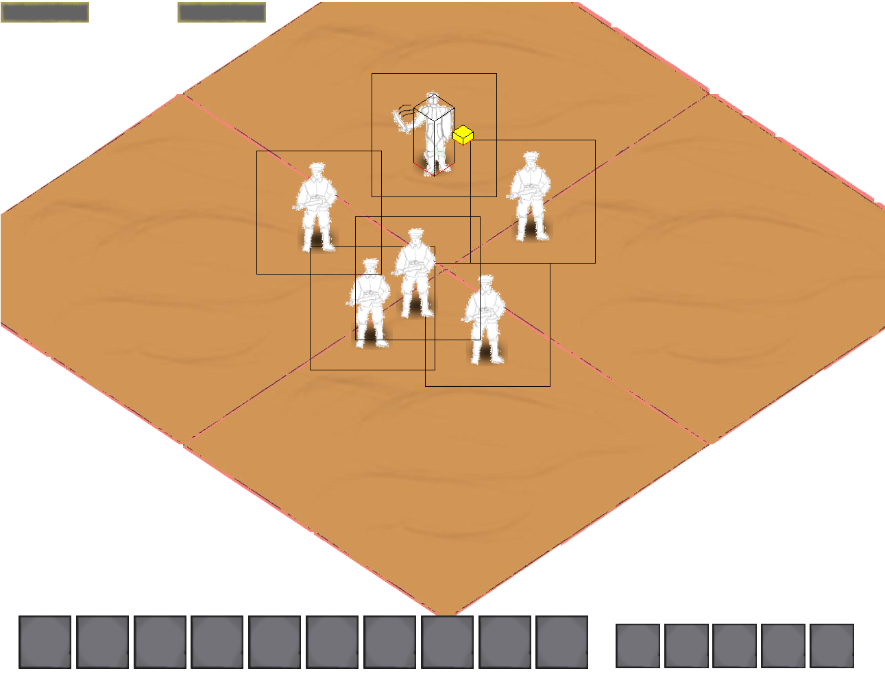
Game in early development.
When you start the game, you will face Nazis who chase you. In this screenshot the character to control is the figure swinging his sword at the Nazis.
The two bars on the upper left corner are bars to show your health and how much experience you have as a percentage to what you need for the next level.
At the bottom, the bigger boxes are your action bars where you can put abilities to more easily use them.
The smaller boxes are, from left to right, buttons to:
1. Quit the game
2. Open the quest log
3. Open the book of abilities
4. Open the Stats and Perks window
5. Open your inventory and the equipment slots
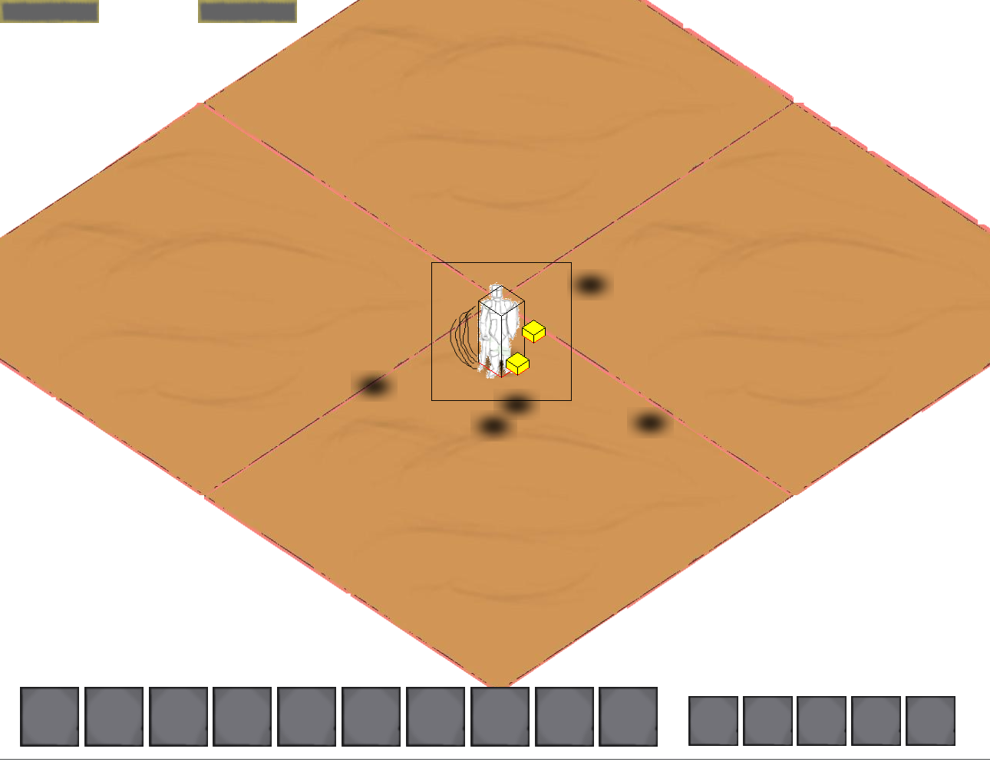
As you slay the Nazis they will leave behind shadows at the place where they died.
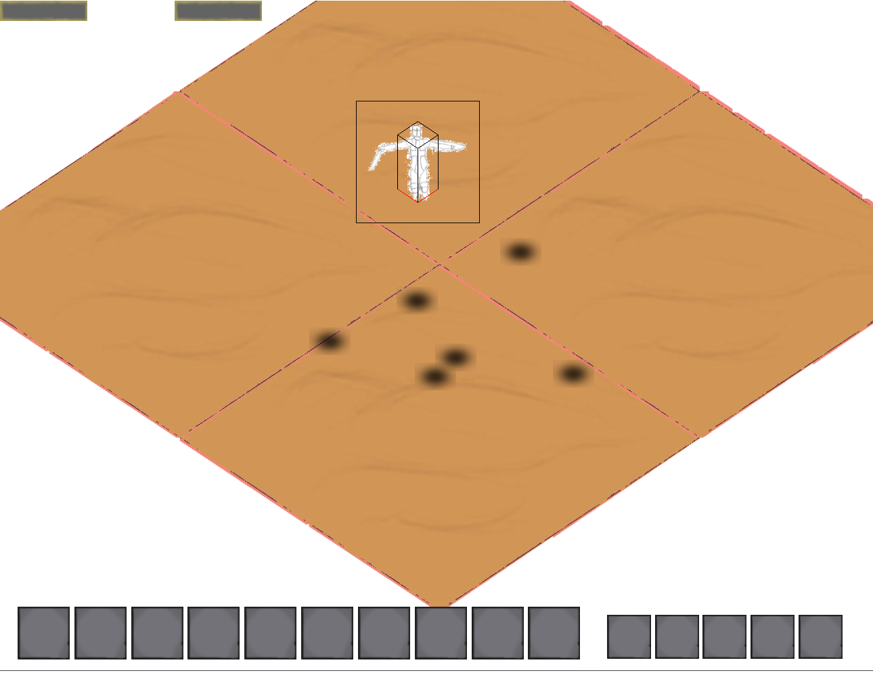
Your character is able to jump!
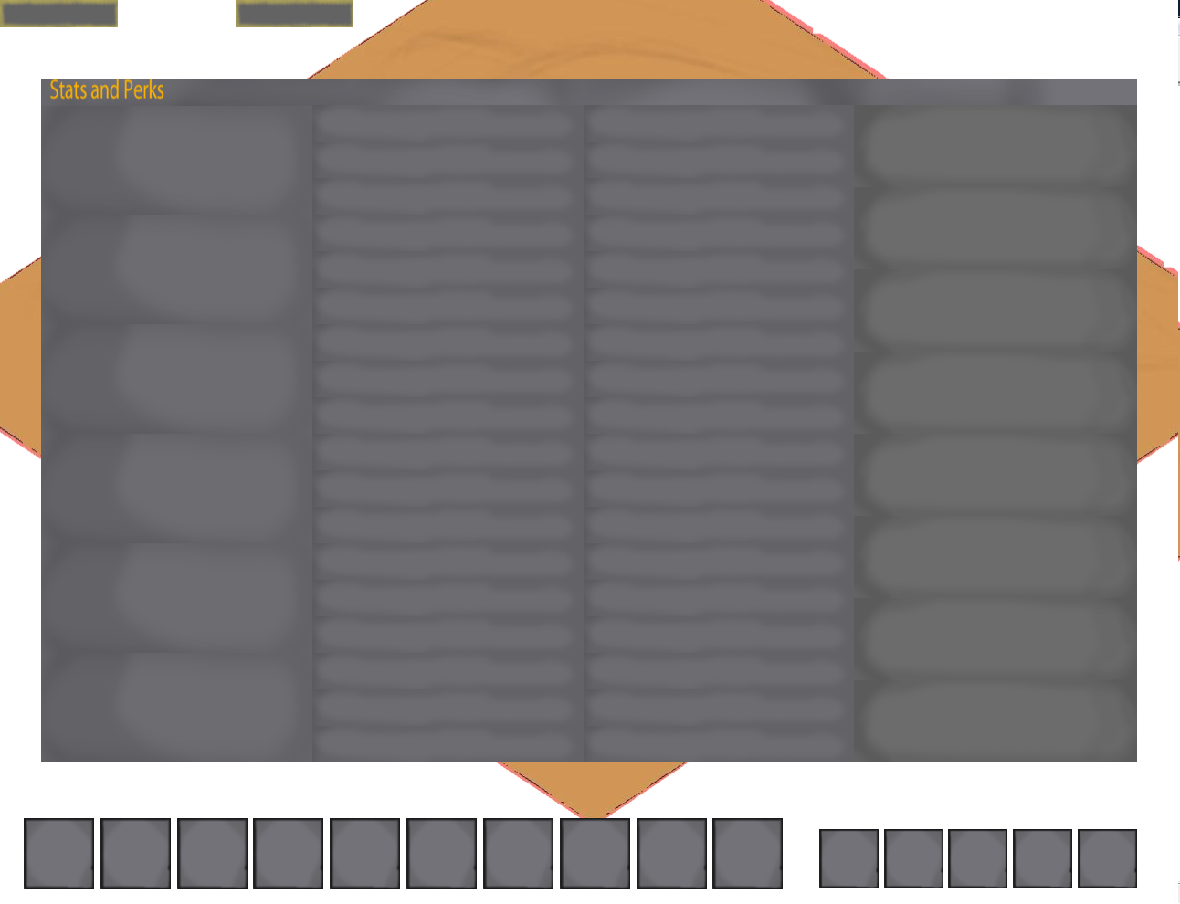
The Stats and Perks window lets you choose perks (on the left side of the window), show what perks you have (in the middle), and increase in level with a stat (on the right side of the window).
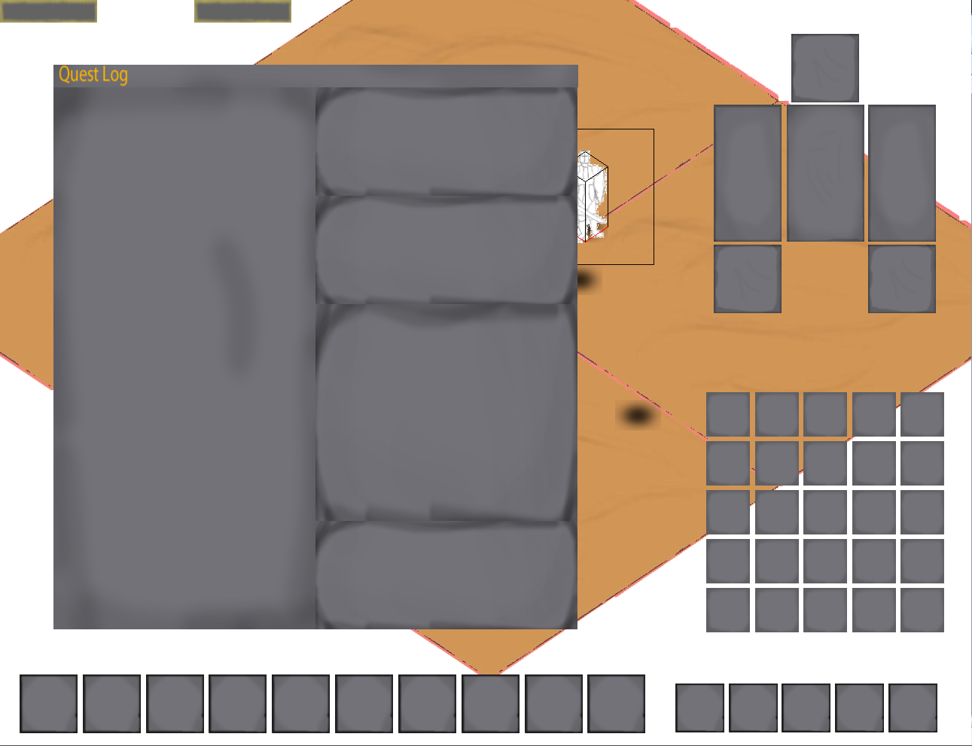
The quest log has a list of what quests you have to the left and to the right you can see:
1. The name of the quest
2. The quest objectives
3. The description of the quest
4. The quest reward
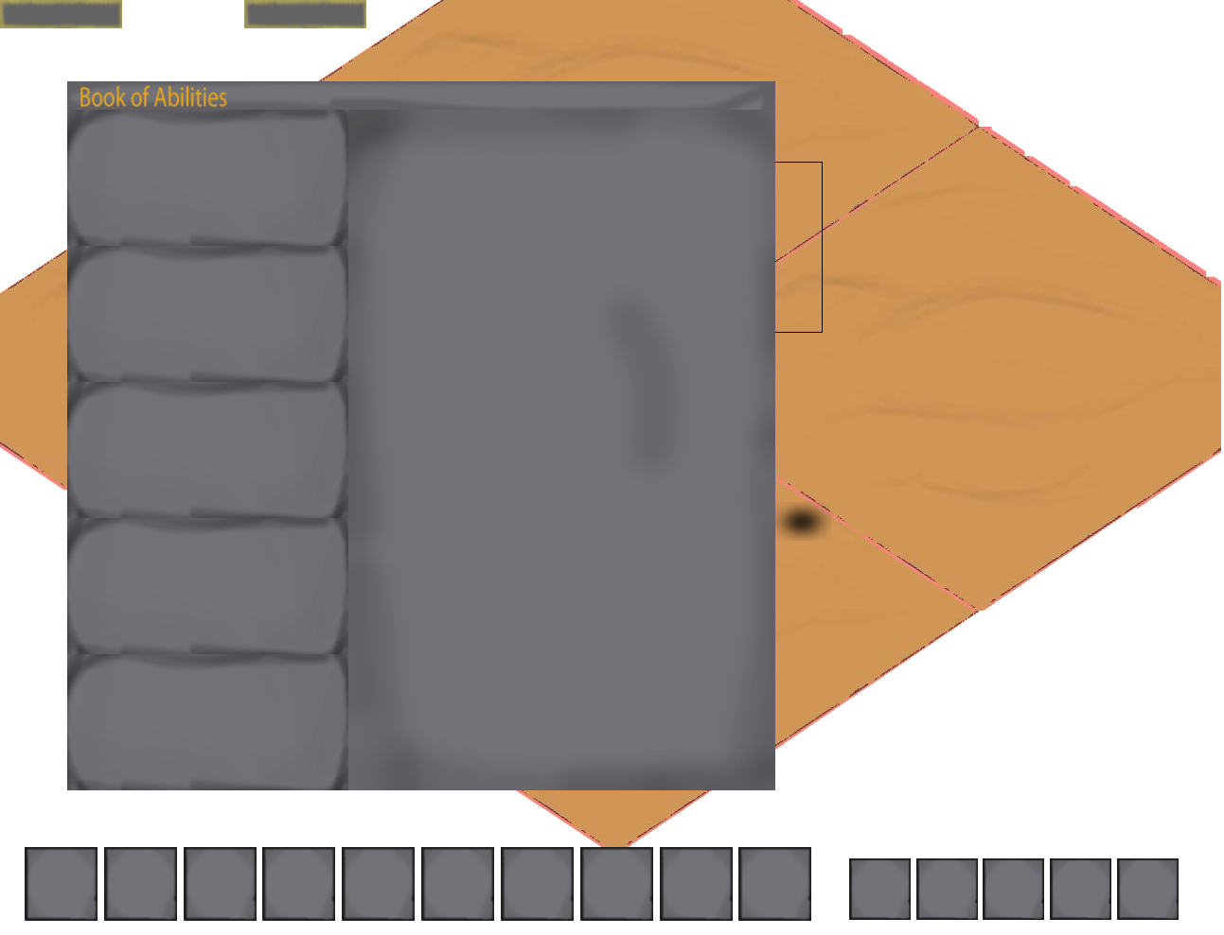
In the book of abilities you have the kind of ability (offensive, healing, technology, holy, unholy) to the left and when one of these is chosen, a list of abilities that you have will appear to the right. The abilities have a box as big as an action bar with a picture representing the ability, the name of the ability, the possible max range from which the ability can be used from, and the description of the ability

ABILITIES
Your character has at the start of the game the ability to hit single enemies with a normal swing with your sword. Later on in the game you learn to do more advanced moves with the weapon of your choice. A list of abilities is listed below.

Whirl
Requires melee weapon
1 meter range
Make a whirl with your melee weapon, damaging all enemies around you.

Charge
Requires melee weapon
5 meter range
Charge at your enemy, knocking them unconcious for 4 seconds.

Power Strike
Requires melee weapon
Put all your strength in one strike, doing enormous damage, but reducing your defence by 30% for 5 seconds after doing this.

DEUS VOLT
Requires Christian faith
Become invulnerable for 10 seconds.

Holy cross
Requires Christian faith
Cast a cross at the enemy, damaging them. Damage is based on strength.

Howl
Frightens enemies within a distance of 5 meters, decreasing their defence by 20% for 5 seconds.

Charm
Requires 30 in charm
Charm an ally to follow you into battle.

Surgery
Requires 50 in surgery skill
Heals your target by 30% of their full health. Only usable when target is below 20% of total health.

Split the Red Sea
Splits your enemy vertically, killing him instantly.

Hasty shots
Requires ranged weapon
Increases shooting speed by 50% for 10 seconds.

Double tap
Requires ranged weapon
Shoots two shots rapidly at the two closest enemies.

Cripple
Requires ranged weapon
Cripple your enemy for 6 seconds by shooting at his legs.

Groin shot
Requires ranged weapon
Stun your enemy for 6 seconds by shooting at his groin.

When the lights are down
Requires the perk Faded
Blinds all enemies around you for 15 seconds.

PERKS
When advancing in level you get to choose a perk that strengthens a specific way of battling. The perk you choose
also decides what abilities the modern British troops are able to teach you, as you need certain knowledge in the
chosen way of battling to learn an ability of that kind.

Level 1 perks

Faster equals better (4 ranks)
Learn to use your weapons more skilfully, attacking 3/6/9/15% faster with them.

Sharpener (4 ranks)
Sharpen your weapon, making it pierce through your enemy’s armour, reducing their defence by 3/6/9/15%.

Engineer (4 ranks)
Learn engineering, gaining 5/10/15/30 technology skill.

Handsome (4 ranks)
Become more handsome, gaining 5/10/15/30 charm skill.

Marksmanship (4 ranks)
Increase the range from which you can shoot with ranged weapons by 2/4/6/10 metets.

Level 4 perks

Raw Strength (4 ranks)
Requires 30 in strength
Become stronger, causing 3/6/9/15% more damage with melee weapons.

Grease (4 ranks)
Requires 30 in ranged skill
Lubricate your ammo in grease, increasing attack speed with ranged weapons by 3/6/9/15%.

Obsessed with Weapons (4 ranks)
Requires 15 in strength and 15 in melee skill
You are obsessed with melee weapons. You gain 5/10/15/30 in melee skill.

Bless thy companion (4 ranks)
Requires 40 in charm skill
Buffs your companion, increasing his health and damage by 2/4/6/10%.

Splatter (4 ranks)
Requires 40 in technology skill
Your explosives damage an additional radius of 0.5/1/1.5/3 meters.

Level 8 perks

Mortal Wounds (4 ranks)
Requires 50 in strength
Your melee attacks cut wounds into your foe, making him bleed for 5/10/20/40 damage every 3 seconds.

Faded (4 ranks)
Requires 50 in melee skill
You are faded, reducing the chance to be hit by 4/8/12/20%.

Double the explosion (4 ranks)
Requires 50 in technology skill
Instead of using one explosive at a time, you use two, causing 120/140/160/200 damage with explosives.

Venomous Ammo (4 ranks)
Requires 50 in ranged skill
Lubricate your ammo in venom, poisoning your target, reducing their damage by 5/10/15/25.

Threatening (4 ranks)
Requires 50 in charm skill
Your enemies consider your companion a bigger threat, making it more likely for them to attack him before you.

Level 12 perks

Alter Time (4 ranks)
Requires atheist faith
Gain control of time, slowing all enemy actions by 5/10/15/25%.

Carried by God (4 ranks)
Requires Christian faith
Gain a passive regeneration effect, healing yourself and your companion for 3/6/9/15 health every 3 seconds

Holy Prayer (4 ranks)
Requires Christian faith
When health is dropped below 30% you gain an extra 5/10/15/25% of your total health for 10 seconds. After the time has passed, the health is lost.

Unholy Prayer (4 ranks)
Requires Satanist faith
When health is dropped below 30%, you damage all enemies around you for 15/30/45/75 damage.

Meltdown (4 ranks)
Requires atheist faith
Your explosives cause a minor meltdown, leaving a fog of radioactive particles that make your enemy 5/10/15/25 weaker while standing in the fog.
Level 16 perks

One Step Ahead (4 ranks)
Requires atheist faith
See into a close future while fighting, reducing enemys' chance to hit you by 10/20/30/40%.

Death (4 ranks)
Requires Satanist faith
Get a 2/4/6/10% chance to spawn Death when damaging your enemy with melee or ranged weapons. Death kills your target instantly.

Hell on Earth (4 ranks)
Requires Satanist faith
Summon a demon from Hell that shares the damage you take by 5/10/15/25% and fights your enemies.

Missionary (4 ranks)
Requires Christian faith
God awards you one of his angels to heal you because you have converted people to Christianity.
The angel grows stronger for every rank in this perk.

Level 20 perks

Angel wings (4 ranks)
Requires Christian faith
Gain the wings of an angel, making it possible for you to fly.

Nazi zombies
Requires Satanist faith
Dead Nazis turn into ally zombies. You can have up to 3 zombies.

The running man
Requires neutral faith
Increases your running speed by 50%.

